Environmental Monitoring System Manual

Contents

Purpose 1

Environmental Guidelines 1

Safety Concerns 2

Set Up 2

Assembly 2

Part Removal 2

Part List 2

Air 2

Water 3

Climate/Sound 3

System 3

Budget 3

Data Storage 3

Lifetime Expectancy 4

Disposal Process 4

Contact Information 4

# Purpose

Current environmental monitoring systems are often expensive and not accessible to the public. This project seeks to create an affordable, open-source monitoring device that enables individuals to gather data on air, noise, water pollution, and climate, fostering community-based environmental awareness.

## Environmental Guidelines

Summary:

These Guidelines are the

**CO2 (Carbon Dioxide)**

* **Workplace Exposure Limits**: The Occupational Safety and Health Administration (OSHA) permits a CO2 exposure limit of 5,000 ppm over an 8-hour workday. For short-term exposure, a 15-minute average limit is 30,000 ppm.
* **Recommendation**: Ensure CO2 levels remain below 5,000 ppm in workplaces. Higher levels can cause fatigue, dizziness, and respiratory issues.

**TDS (Total Dissolved Solids) in Water**

* **EPA Guidelines**: The U.S. Environmental Protection Agency (EPA) recommends a maximum concentration of 500 mg/L of total dissolved solids (TDS) in drinking water. This is a secondary standard and relates to water quality aesthetics (taste, odor, and color), not health risks.
* **Recommendation**: Keep TDS levels in drinking water below 500 mg/L to ensure acceptable taste and prevent scaling in pipes.

**Turbidity in Water**

* **EPA and WHO Guidelines**: The EPA sets the maximum turbidity level for public water systems at 1 NTU, with the World Health Organization (WHO) also recommending a level below 1 NTU. High turbidity can indicate contamination and may harbor pathogens.
* **Recommendation**: Maintain water turbidity levels below 1 NTU to ensure safe drinking water and minimize contamination risks.

**Water Temperature**

* **Effects on Aquatic Life**: Water temperature plays a crucial role in maintaining the health of aquatic ecosystems. Sudden changes can stress aquatic life and influence dissolved oxygen levels. Monitoring temperature trends in natural water bodies can help prevent environmental stress.

**Air Temperature**

* **Heat Index Classifications (NWS)**:
  + **Caution**: 80°F–90°F
  + **Extreme Caution**: 90°F–103°F
  + **Danger**: 103°F–124°F
  + **Extreme Danger**: 125°F or higher
* **Recommendation**: Monitor outdoor temperatures, particularly during heatwaves, and follow safety measures when heat index values approach "extreme caution" or higher.

**Humidity**

* **EPA Indoor Guidelines**: Indoor humidity should be maintained between 30–50% to prevent mold growth and minimize respiratory issues like asthma or allergies.
* **Recommendation**: Ensure indoor environments maintain this humidity range to prevent moisture-related health hazards.

**Wind Speed**

* **OSHA and NWS Guidelines**: OSHA considers winds above 40 mph as high winds. The National Weather Service defines damaging high winds as those with sustained speeds above 58 mph.
* **Recommendation**: Monitor wind speeds and issue warnings when speeds exceed 40 mph to ensure safety during outdoor work and events.

**Noise Levels**

* **EPA Guidelines**: A day-night average noise level above 75 dB is considered "unacceptable," while levels between 65-75 dB are "normally acceptable." Exposure to levels above 85 dB can cause hearing damage.
* **Recommendation**: Keep noise levels below 65 dB for acceptable residential and environmental quality. In industrial or public areas, implement noise control measures when day-night averages exceed 75 dB.

**Particulate Matter (PM2.5)**

* **EPA and WHO Guidelines**:
  + **EPA Standards**: Annual PM2.5 limit of 9 µg/m³ and a 24-hour limit of 35 µg/m³.
  + **WHO Recommendations**: Annual average should not exceed 5 µg/m³, and the 24-hour average should stay below 15 µg/m³.
* **Recommendation**: Monitor PM2.5 levels in the air and ensure concentrations remain below these limits to minimize health risks, especially respiratory and cardiovascular issues.

**pH Levels**

* **EPA Water Quality Guidelines**: The acceptable pH range for drinking water is between 6.5 and 8.5. For freshwater aquatic life, pH levels between 6.5 and 9 are generally suitable.
* **Recommendation**: Regularly measure the pH of water bodies and drinking water. Deviations from these ranges may signal contamination or environmental stress.

**Dissolved Oxygen (DO)**

* **Aquatic Life Guidelines**: DO levels below 5 mg/L can stress fish, and levels below 3 mg/L are too low to support aquatic life.
* **Recommendation**: Maintain DO levels above 5 mg/L to ensure the health of aquatic ecosystems. Low DO levels may indicate pollution or excessive organic matter.

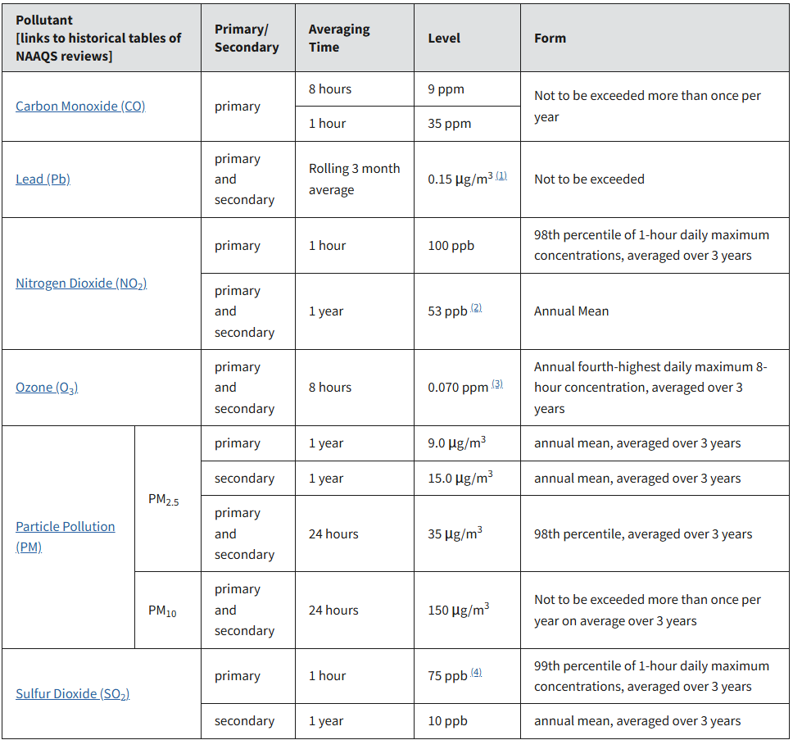

**General Safety Recommendations**

* Ensure continuous monitoring of all parameters to maintain environmental safety.
* Establish alert systems for conditions exceeding recommended thresholds (e.g., CO2 levels, PM2.5 concentrations, noise levels).
* Maintain a regular data review and reporting system to ensure compliance with local regulations and international guidelines.

By following these guidelines, users can ensure the environmental monitoring system provides valuable data to protect human health, maintain water quality, and safeguard ecosystems.

# Safety Concerns

Summary:

1. System recommendations and process of handling

# Set Up

## Assembly

1. Order Parts
   1. List of parts in the base design
   2. List of parts necessary
   3. PCB files and location to send to get 1
   4. Encloser design and how to get it
2. Sensor Code:
   1. Go to GitHub link
   2. Download code
   3. Remove unnecessary code
   4. Upload to Arduino
3. Assemble together
   1. Breadboard wiring
   2. PCB placements
   3. Encloser assembly
4. Testing
   1. Warmup phase
   2. Easiest method to check accuracy
      1. Table of methods
5. Location
   1. Outdoors
   2. Indoors

## Part Removal

Summary:

1. Recommended parts
   1. Air Quality section (excluding O3)
   2. Water Quality ()
   3. GPS
2. Less concerning parts
   1. Noise monitoring
   2. Temperature/Humidity

# Part List

Organization example:

Specification

* Type
  + Name (Code link, Cost, Technical document link)

## Air

* CO
  + ()
  + ()
* CO2
  + SEK-SCD41 (Code, $ , Data_Sheet )
* Ozone
  + SEK-SCD41 (Code, $ , Data_Sheet )
* Methane
* PM2.5
  + PMS5003(Code, $25, Data_Sheet)
* PM10
  + PMS5003(Code, $25, Data_Sheet)

## Water

* Dissolved Oxygen
  + SEN0237-A (Code, $, Data_Sheet)
* PH
* Turbidity
* TDS
  + SEN0244 (Code, $11.8, Data_Sheet)

## Climate/Sound

* Noise/Duration
  + I2C Decibel sound level meter module-ESP32(Code, $25, Data_Sheet)
  + Taidacent Decibel Detection Module (Code, $45, Data_Sheet)
* Temperature
  + SEN0137(CODE, $3.00, [Data Sheet](https://mm.digikey.com/Volume0/opasdata/d220001/medias/docus/2331/SEN0137_Web.pdf?_gl=1*9rjg1b*_up*MQ..&gclid=Cj0KCQjwxsm3BhDrARIsAMtVz6MhrgvLNACTwJVxdRy08W3e1CQLF2XQ7oGnFLRKQ5s8VSNOu0JSksUaAnkSEALw_wcB&gbraid=0AAAAADrbLlgUgtqZiYHKHVpeN-YpI-cro))
  + 828-1063-2-ND(CODE, $16.50, [Data Sheet](https://www.bosch-sensortec.com/media/boschsensortec/downloads/datasheets/bst-bme280-ds002.pdf))
* Humidity
  + SEN0137(CODE, $3.00, [Data Sheet](https://mm.digikey.com/Volume0/opasdata/d220001/medias/docus/2331/SEN0137_Web.pdf?_gl=1*9rjg1b*_up*MQ..&gclid=Cj0KCQjwxsm3BhDrARIsAMtVz6MhrgvLNACTwJVxdRy08W3e1CQLF2XQ7oGnFLRKQ5s8VSNOu0JSksUaAnkSEALw_wcB&gbraid=0AAAAADrbLlgUgtqZiYHKHVpeN-YpI-cro))
  + WWZMDiB(CODE, $1.997, Data_Sheet)
* Pressure
* GPS
  + GY-NEO6MV2(CODE, $5.50, [Data Sheet](https://components101.com/sites/default/files/component_datasheet/NEO6MV2%20GPS%20Module%20Datasheet.pdf))

## System

* Arduino/add ons
  + Uno R4 WiFi(Code, $23)
  + Nana ESP32(Code)
  + ESP9266()
* Battery
* DC Buck Converter
  + B00C0KL10M ($12.15, Data_Sheet)
  + SD-15A-5 ($14.18, Data_Sheet)
  + U6223 ($7.945, Data_Sheet)
  + 1538-1065-ND ($14.95, Data Sheet)
* Solar Charge Controller
* Solar panel
* Etc
  + Decoder 74HC154PW,118 ( )
  + Not Gate SN74LS04N 74LS04 74LS Hex 1-input inverter ()

## Budget

# Data Storage

Summary: A main feature of the project is to provide people with an abundance of data and to do this storage and access must be considered. A starting point is that the device has the ability to export to a

Database link:

# Lifetime Expectancy

Summary: Based on the parts in this system the lifetime expectancy is

# Disposal Process

Summary:

# Contact Information

EcoSense:

Github:

Database: